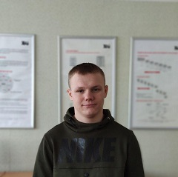


Education
Kharkiv National Aerospace University | 2018 - 2022

Faculty of Software Engeneering and Business,
department of Software Engeneering, specialization Software Engeneering

Vitaly Basanets

.Net developer

Personal information

City:

Kharkiv

Phone:

+38(067) 98-254-60

E-mail:

w.basanets2301@gmail.com

Date of birth:

23-01-2001

GitHub:

GitH https://github.com/vitalik23

 |  |  | Languages
Work Experience |  |  | Languages

.Net courses in SigmaSoftware start: 01-10-19 – end: 27.12.19

Team development project “Course management system”
Independent development project “Express freight delivery”

Accomplishments:

Database Design

Working with GitHub

Creating a page views

Creating logic of the web-application


Russian

Ukrainian

English

Technical skills

Programming languages: C#, Java

Databases: MS SQL Server

Web technologies: HTML, CSS, Java Script

Technologies: ASP.NET MVC, Entity Framework

Development tools: Visual Studio 2017-19, SQL server management studio, Visual Studio Code, Atom

Operating system: Windows 7/10

System control versions: Git

Development methodology: Scrum

Portfolio


Express freight delivery:
https://github.com/vitalik23/CargoExpress



Personal qualities

Responsible, punctual, focused, calm, quiet, friendly, teamwork.

